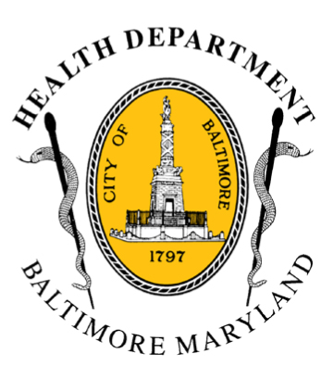
BCHD PRESS RELEASE
Baltimore City Health Department
1001 E. Fayette Street • Baltimore, Maryland 21202
Stephanie Rawlings-Blake, Mayor
Leana Wen, M.D., Commissioner of Health

FOR IMMEDIATE RELEASE
Media Contacts:

Michael Schwartzberg, PIO
O: (443) 984-2623 C: (443) 462-7939 E: michael.schwartzberg@baltimorecity.gov

Jennifer Fuson, Communications Specialist
O: (410) 545-0823 E: Jen.Fuson@baltimorecity.gov

Baltimore City Health Commissioner Declares Code Red Heat Advisory For Tuesday; First Of The Season

BALTIMORE, MD (June 22, 2015) – With the heat index expected to be at 105 degrees tomorrow, Baltimore City Health Commissioner Dr. Leana Wen has issued a Code Red Heat Advisory for Tuesday, June 23. The heat index is a measure of air temperature and relative humidity and indicates how hot it feels to individuals outside. This is the first Code Red of the season.

“Hundreds of people die every year from heat-related illness,” said Dr. Wen. “Heat is a silent killer and a threat to the health of everyone in our city, particularly the young, the elderly and those with chronic diseases. In weather like this, it’s important for everyone to protect against hyperthermia and dehydration.”

With the Code Red Heat Advisory declaration, cooling centers will be open at five Community Action Partnership Center locations and at six senior centers from 9 a.m. to 7:00 p.m. offering cold water and air-conditioned space for residents without access to cool air in their homes. A list of these centers is available on the Health Department website at http://health.baltimorecity.gov/emergency-preparedness-response/code-red.

During periods of extreme heat, the Baltimore City Health Department recommends that city residents:

- Drink plenty of water and avoid alcohol and caffeine
- Reduce outside activities and stay inside in air-conditioned locations
- Never leave children or pets alone in closed vehicles, even for short periods of time
- Check on older, sick, or frail neighbors who may need help responding to the heat
- Watch out for signs of heat exhaustion and heat stroke, which include:
- Confusion
- Hot, dry, flushed skin or cool and clammy skin
- Lighheadedness
- Nausea
- Call 911 immediately if any of these symptoms occur

In 2014, there was 1 Code Red declaration issued and 3 hyperthermia-related deaths. In 2013, there were 6 Code Red declarations and 2 hyperthermia-related deaths.
###

